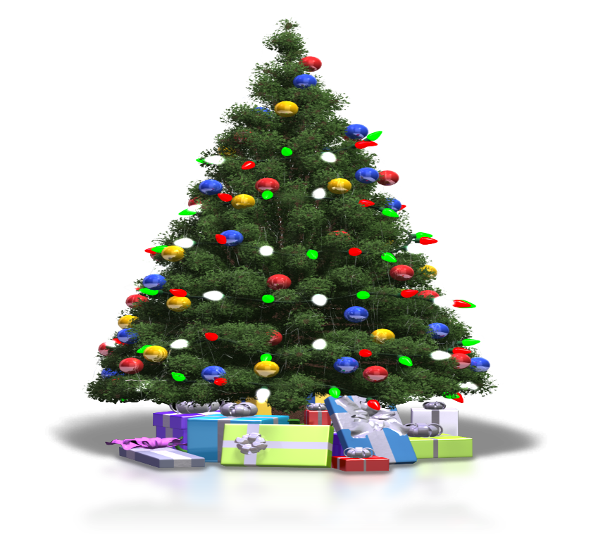
This Photo by Unknown Author is licensed under CC BY-NC
YOU ARE INVITED TO ATTEND THE
CWA CHRISTMAS SOCIAL!
(CWA MEMBERS ONLY)
TUESDAY, DECEMBER 9, 2025
4:30PM – 9:00PM
CWA LOCAL 3406
THE UNION HALL
611 SAINT JOHN STREET
LAFAYETTE, LA 70501

GUMBO, APPETIZERS, DESSERTS AND NON-ALCHOLIC BEVERAGES, MUSIC, DOOR PRIZES, AND CHRISTMAS GAMES WILL BE PROVIDED.
YOU ARE WELCOMED TO WEAR FESTIVE CHRISTMAS ATTIRE

(PRIZES WILL BE GIVEN FOR THE MOST CREATIVE CHRISTMAS ATTIRE)

